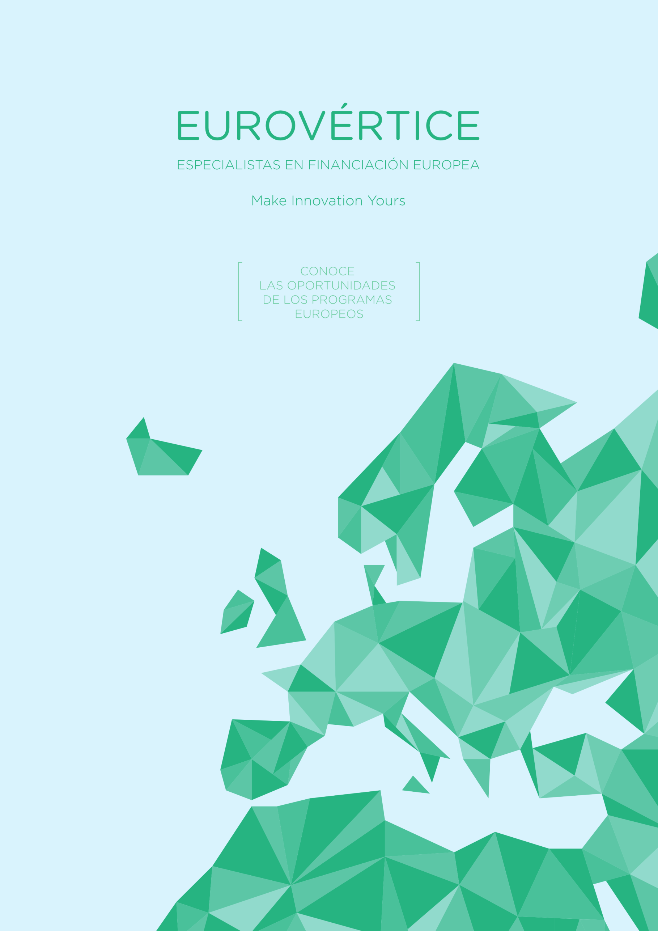

EUROPE FOR CITIZENS
Programme: | EUROPE FOR CITIZENS – Strand 2: Democratic engagement and civic participation
- General objective
The project will raise awareness in general society about the situation of homeless people and other vulnerable groups and encourage civic participation of citizens at EU level by developing their understanding of the EU policy about intercultural dialogue and social inclusion.
To achieve this objective, it is necessary to work together, from local to European level, exchanging knowledge and experience and through civic engagement be able to stimulate debates and reflexion to propose practical solutions through cooperation.
- Possible activities:
- Gathering opinions to know the state of the art and the perspective from different target groups in two senses: opinion of general society about vulnerable groups, especially homeless and vice versa, to know the opinion of these vulnerable groups about general society.
- Promotion of societal engagement and solidarity: The results of the activities of the first phase will be deeply analysed within the partnership and new debate actions will be designed and implemented to achieve civic engagement and to produce highly innovative tools to support the EU policy on intercultural dialogue and social inclusion.
- Developing volunteering with vulnerable groups, especially homeless and promoting solidarity thanks to the tools designed in point 2.
- Testing of the innovative tools and creation of a guidelines with main project results.

Applicant | Fundation Jesús Abandonado (Well-known association dealing with homeless (Murcia – Spain)
Deadline to answer the partner search | 24/05/2019
Budget | Maximum Budget 150.000 €
Project duration | 18 months
Type of Partners: | - Institutions dealing with homeless  - NGOs  - Public local and regional authorities dealing with social inclusion, intercultural dialogue, etc.  - Universities  - Organisations representing civil society  - Cultural and educative institutions
Contact person: | Consuelo García  EuroVértice Consulting (Murcia, Spain)  consuelo.garcia@eurovertice.eu  Phone number: +34 968 277 845

